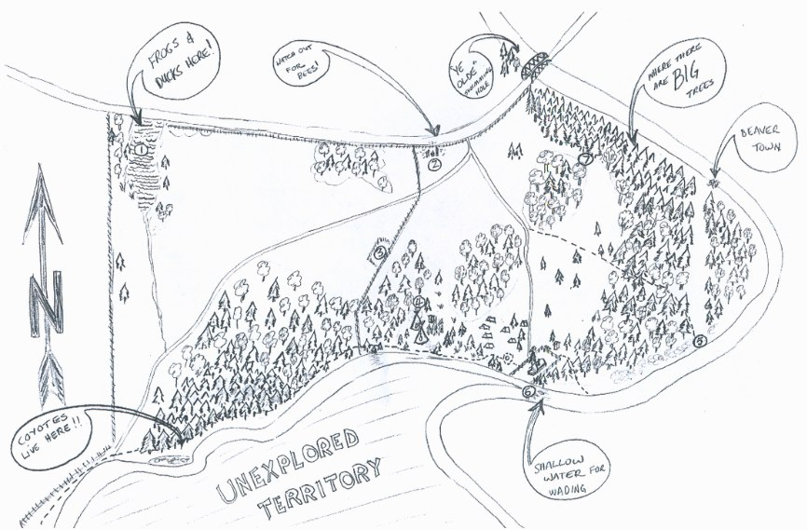
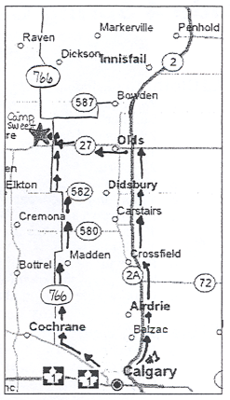
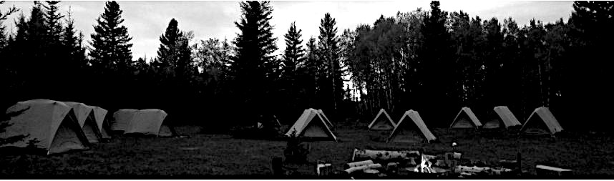
Grade and Dates here
CAMP SWEET 2014
Camp Sweet is located 10 miles west and 2 miles north of Olds, Alberta on a pocket of land that has served as a site for fall and spring camps at Connect Charter for over a decade. Camp Sweet is bordered by a wetland, forested areas and situated at the confluence of Dog Pound creek and the Little Red Deer River. There are two 28 foot tipis, portable toilets and a temporary dining shelter on site. This booklet contains key information about the Camp Sweet program as well as a program itinerary, student packing list, menu.

Health information and student consent forms must be returned to your child’s homeroom teacher no later than insert dates here.

Key Information
Depart Connect | 9:30 am
Return to Connect | 3:00 pm  *Please make firm arrangements for student pickup no later than 3:00pm
Cost | There is no fee for this camp
Transportation | Transportation will be provided by Traxx Buslines
First Aid | The teachers on this trip are First Aid certified. Emergency services in the area have been notified of our dates and location. In the unlikely event that medical attention is needed, Olds hospital is located less than fifteen minutes from the site.  *Please send student medication in a clearly marked container with their name and instructions
Staff | 2 teachers  1 administrator
Volunteers | We require the help of parent volunteers to make this trip happen. We need a minimum of 4 parents to travel wtih the group. The primary responsibilities of the volunteers will be to help prepare and cook meals, to assist students with cleanup, and to help supervise students. If you are interested in volunteering, please contact your child’s homeroom teacher directly so that they can provide you with the volunteer application.
Food | All meals are provided with the exception of lunch on the first day. A menu has been attached to this document for students with dietary concerns. Students, please pack a waste-free lunch from home, a reusable water bottle and a nut-free snack to share with the group.
Curricular Connections | Students will:  - Develop basic knowledge, skills and attitudes necessary for safe, comfortable outdoor experiences  - Develop understanding, respect and appreciation for self, others, and their views  - Develop awareness and appreciation of living things and an understanding of basic ecological processes  - Develop skill, judgment, confidence and sensitivity in a wide range of environmentally responsible activities outdoors  - Develop lifestyle strategies that foster contact with the natural world, encourage responsibility for local and globa environments and encourage living in harmony with others
Consent Forms | For the safety of your child, it is essential that the information we have on file is current. Allergies (mild or severe) as well as food sensitivies need to be identified and brought to our attention. Please make sure you complete the health information section of this booklet.

Trip Itinerary
Time | Day 1 | Day 2 | Day 3
8:00 |  | Breakfast | Pack
9:00 | Load buses |  | Breakfast
9:30 | Depart Connect
11:00
12:00 | Arrive at Camp Sweet - lunch | Lunch | Lunch
1:00 |  |  | Depart camp
2:00
3:00 |  |  | Arrive at Connect
4:00
5:00 | Supper | Supper
6:00
7:00
8:00
9:00 | Campfire | Campfire
10:00 |  | Night hike
11:00

Packing List

Clothing
- 2 pair of shorts
- 2 pair of pants (synthetic)
- 1 pair of long underwear (tops and bottoms) - for warmth and to sleep in
- Swimsuit (for the river)
- 2 t-shirts
- 1 long-sleeved shirt (synthetic)
- 2 pairs of warm socks
- 3 pairs of regular socks
- 3 pairs of underwear
- Warm sweater (not cotton)
- Warm jacket (down or fleece - winter jacket recommended)
- Toque
- Gloves or mitts
- Water shoes (rubber boots, crocs, sandals)
- Comfortable walking shoes (runners or hiking boots)
- Waterproof rain gear (tops and bottoms)

Sleeping Gear
- Warm sleeping bag (-7C minimum)
- Sleeping pad
- Pillow

Personal Gear
- Toothbrush and toothpaste
- Towel
- Sunscreen
- Bus spray
- Lip balm
- Labeled 250 mL water bottle
- Sunglasses
- Hat with a peak
- Flashlight or headlamp
- Garbage bag for dirty clothes

Food
- Waste-free bag lunch for first day (please pack your own - you will be expected to eat everything)
- Snack for group

