FORT STEELE
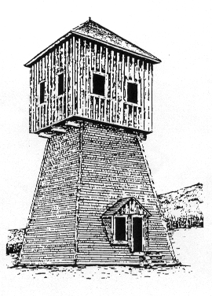
HISTORY LAB
2014

PARENT BOOKLET
Grade 5
CONNECT CHARTER SCHOOL
MAY 1 – 13, 2014
FORT STEELE HISTORY LAB
FORT STEELE, BC
EMERGENCY CONTACTS:
FORT SECURITY 250-417-6000
SITE SUPERVISORS:
SCOTT PETRONECH 403- 819-9192
RON SWEET 403-880-2018

TRIP # 1 May 1 - 4
Grade 5.1 Jocelyn Monteith
TRIP # 2 May 4 - 7
Grade 5.2 Margaret Leland

TRIP # 3 May 7 - 10
Grade 5.3 Valerie Barnes
TRIP # 4 May 10 - 13
Grade 5.4 Gail Stevenson

Fort Steele History Lab
General Information
The Fort Steele History Lab was developed by Ron Sweet in 1975 as a Social Studies immersion activity. Since its inception, the History Lab has introduced students to the challenges faced by indigenous people, early settlers, and the North West Mounted Police as they all sought to meet their diverse needs. Park interpreters deliver the programs for the Pioneer Home, Horse Study, and Blacksmithing components of the History Lab. Connect staff and parent volunteers administer all other aspects of the program.

COST
The cost of the Fort Steele History Lab experience is generally borne by parents. Board policy states “…no eligible student may be denied participation solely on the basis of inability to pay the cost.” If a problem exists in this area, please contact the school administration. The cost of the 2014 program is $280 per student. Payment should be made on line through the Family Zone of the Connect website. Alternatively, cheques should be made payable to Connect Charter School. On the final day of the experience, students will be able to go shopping at the Fort Steele gift shop. We suggest that their spending money not exceed $20.00.
TRANSPORTATION
Transportation to and from Fort Steele is via washroom-equipped chartered highway coaches. For each trip the bus will be ready for loading at the school at 7:00 am and will depart at 7:30 am. The bus will return to the school at approximately 7 pm on the final day. Please note that on the return trip the bus stops at Radium Hot Springs to allow students time to enjoy a swim in the public swimming pool. Admission to the pool is provided.
FOOD
We ask each student to bring:
- 2 dozen cookies (see snack suggestions following menu);
- a hearty bag lunch for the first day (to be eaten on arrival at the Fort).
MEDICATION AND FIRST AID
Please complete the Health Information Form included with this booklet. Any medication that your child is taking during the History Lab must be clearly marked with their full name and administration procedures and be given to the teacher. The staff is equipped and trained to handle minor ailments and injuries. In the unlikely event of serious illness or injury, an emergency vehicle is available for transportation to the nearest hospital located 14 km away in Cranbrook, BC. Parents will be notified immediately. Please note emergency contact numbers at the front of this booklet.
What To Take
Please review this list with your child so that they know what they are taking. Please label everything and pack all items into a large duffle bag or suitcase. Please do not use plastic bags. Other than possibly a digital camera, please do not bring electronics (iPods, handheld gaming systems, cell phones etc.), or knives of any kind.

Clothing & Sleeping Items
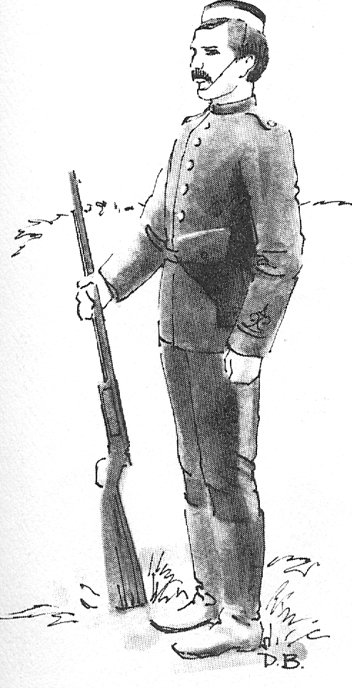
- ______ 3 t-shirts
- ______ 2 long sleeved shirts
- ______ 4 pairs of underwear
- ______ 1 pair of long johns
- ______ 3 pairs of pants
- ______ 1 pair of shorts
- ______ 1 sweater
- ______ 1 light jacket
- ______ 1 winter jacket
- ______ 1 hat or cap
- ______ 1 toque
- ______ 1 pair of gloves or mitts
- ______ 4 pairs of socks
- ______ 1 set of pajamas
- ______ 1 swimsuit
- ______ 1 pair of runners
- ______ 1 pair of rubber boots
- ______ 1 raincoat or poncho
- ______ 1 winter weight sleeping bag (or 2 summer weight bags)
- ______ 1 pillow
- ______ 1 flashlight (with extra batteries)

Personal Hygiene Optional Items
- ______ toothbrush & toothpaste 32. ______ camera
- ______ 1 bar of soap in a container 33. ______ book(s)
- ______ 2 towels (one small, one large) 34. ______ blanket
- ______ comb or brush 35. ______ playing cards
- ______ Chapstick 36. ______ spending money
- ______ plastic cup for brushing teeth

Food & Other
- ______ two dozen cookies (no nuts please)
- ______ hearty bag lunch & reusable water bottle (for the first day)
- _____ backpack (that can be carried, not wheeled)

FORT STEELE HISTORY LAB GRADE 5
FORT STEELE APPRENTICESHIP PROGRAM GRADE 7
MENU: SPRING 2014

ATTN: PARENTS OF STUDENTS WITH DIETARY RESTRICTIONS
PLEASE USE THIS PAGE TO INDICATE MENU SUBSTITUTIONS & RETURN TO YOUR CHILD’S TEACHER
DAY 1 | LUNCH  Grade 5 & 7 | - Bag lunch brought by students
 | SUPPER  Grade 5 & 7 | - Hamburgers (veggie burgers)  - BBQ Sauce for burgers  - Buns  - Cheese, lettuce, tomato, ketchup, relish, mustard  - Tortilla Chips  - Salsa  - Milk/Chocolate milk  - Fruit Salad  - Cookies
DAY 2 | BREAKFAST  Grade 5 & 7 | - Pancakes  - Sausage (chicken apple)  - Syrup  - Margarine  - Orange Juice  - Milk  - Orange slices
 | CREEK LUNCH  Grade 5 | - Hot Dogs (Beef)  - Veggie Dogs  - Buns  - Beans (in tomato sauce)  - Ketchup, Relish, Mustard  - Cookies, Bananas  - Juice Boxes
 | FORT LUNCH  Grade 7 | - Grilled Cheese Sandwiches  - Tomato Soup  - Pickles  - Celery, Carrots, Ranch Dressing  - Milk/Chocolate milk  - Fresh Fruit
 | SUPPER  Grade 5 & 7 | (whole meal provided by Grade 7’s)
DAY 3 | BREAKFAST  Grade 5 | - Scrambled Eggs  - Bacon  - Hashbrowns  - Orange Juice/ Milk
DAY 3  (cont’d) | BREAKFAST  Grade 7 | - Hotel Breakfast (provided by Grade 7’s)
 | FORT LUNCH  Grade 5 | - Grilled Cheese Sandwiches  - Tomato Soup (Campbell’s)  - Pickles  - Raw Veggies, Ranch Dressing  - Milk/Chocolate milk  - Fresh Fruit
 | CREEK LUNCH  Grade 7 | - Hot Dogs (Beef)  - Veggie Dogs  - Beans (Tomato Sauce)  - Ketchup, Relish, Mustard  - Cookies, Bananas
 | SUPPER  Grade 5 & 7 | (whole meal provided by Grade 7’s)
DAY 4 | BREAKFAST  Grade 5 | - French Toast / Syrup  - Orange Juice  - Milk  - Leftover Fruit Salad  - Sausages
 | BREAKFAST  Grade 7 | - Hotel Breakfast (provided by Grade 7’s)
 | LUNCH  Grade 5 & 7 | - Submarine Sandwiches  - Roast Beef, Ham, Chicken (deli)  - Cheese Slices Lettuce, tomato, mayo, mustard  - Pickles  - Milk/Chocolate Milk  - Fresh Fruit

Parent Volunteers
Each class requires five parent volunteers to accompany the group and fulfill specific duties. If you wish to volunteer for the Ft. Steele Apprenticeship Program, please be aware of the following requirements and expectations:
Requirements
- Valid security clearance check on file with Connect.
- Experience in administering to minor injuries; ideally first aid training.
- Physical ability to walk several kilometers and lift moderate weights (e.g. - pails of water).
- Commitment to long, (but rewarding) days that occasionally require independent thinking and action to ensure student safety or to meet program requirements.
Expectations
- Food preparation and cooking for breakfast, lunch, and dinner as required. You may be asked to assume responsibility for ensuring specific students have their dietary needs met aside from the regular food preparation procedures.
- Supervise and participate in post-meal clean up and ensure all food and equipment is properly stored for future use.
- As required, and only within your levels of confidence and competency, chop wood for the stove in the mess hall, and / or supervise students in chopping wood. NOTE: Only those who are experienced and knowledgeable in the safe use of an axe will be permitted to chop wood or supervise students in this activity.
- Enthusiastic participation in activities while leading and supervising students.
- Supervise groups of students during Apprenticeship Program activities as directed by the classroom teacher. This will include, but is not restricted to, a hike around Echo lake, activities in various fort buildings, gold panning on Wild Horse Creek, accompanying students to the recreation center in Cranbrook, and sleeping on the hotel floor to assist in supervising either male or female students at night and ensuring that ‘quiet time’ is respected.
- Administer minor first aid treatments to students as required and become familiar with those students who may require further immediate attention due to potential reactions to allergens, bee or wasp stings, and pollen.
- Fulfill further duties as requested by the classroom teacher, Mr. Scott Petronech, or Mr. Sweet.
Transportation Note:
The coaches that transport students and teachers to Fort Steele can usually not accommodate parent volunteers. It is therefore necessary for one or two parents to drive their own vehicles and take one or two other parents with them. Connect will reimburse fuel expenses, upon submission of receipts, for the designated parents driving vehicles going to Ft. Steele. Once the volunteers for each trip have been identified, we rely on the parents to make arrangements accordingly.

Snack Suggestions

Students have usually been asked to bring a dozen cookies along to camp, to provide a mix of treats for snacks and dessert. Over time, the mix of cookies has slowly changed from almost always homemade to almost never homemade. At the same time, there’s been an increase in the general level of awareness around healthy eating. There’s also been an increase in the number of students with severe allergies and food intolerances.

If you are interested in some ‘new’ recipes, please contact the school. We would be happy to share a list of snack ingredients that parents have sent us over the years.

TO HELP ENSURE THE SAFETY OF OUR STUDENTS WITH ALLERGIES, PLEASE INCLUDE AN INGREDIENT LIST WITH YOUR HOMEMADE GOODIES

Helping your child make homemade cookies, mini muffins, snack loaf is a great way to spend time together and build some kitchen skills.

If you don’t have time to do some pre-camp baking, here are some suggestions for snacks from the grocery store:

Dried fruit (prunes, figs, raisins, Craisins, 100% fruit bars)
Nut-free granola bars
Unsweetened fruit purée cups (such as applesauce)
Fruit cups (such as peaches or mandarin oranges) packed in fruit juice or water

** Please DO NOT SEND juice boxes, candy, chocolate bars or chips **

(Insert Informed consent here)

Health Information Form
NAME: ___________________________________________________________________________________
ADDRESS: _______________________________________________________________________________
BIRTHDATE: _________________________________ HOME PHONE: ______________________________
PARENT / GUARDIAN: ________________________ WORK PHONE: _____________________________
CELL PHONE: ________________________________ EMAIL: ____________________________________
Does your child receive medication? Yes ______ No ______
What type? _________________________________________________________________________________________________
Does or has your child had any illness such as Diabetes: Yes _____ No _____ Asthma: Yes _____ No _____
Allergies: Yes _____ No _____ (State) _______________________________________
Does your child require an Epi-pen? Yes_______ No_______
If your child has a severe allergy and/or requires assistance with administering medication, please complete an “Authorization to Administer Medication and Release of Liability” form (available in the school office).
Has your child been away from home before? Yes _____ No _____
Has your child been on an overnight trip before? Yes _____ No _____
Does your child have any problem of which the staff should be aware? ____________________________________________________________________________________________________________
____________________________________________________________________________________________________________
Will you permit teachers to administer light remedies such as Tylenol, Advil, Benadryl or Pepto Bismol?
Yes _____ No _____
Food Restrictions: ____________________________________________________________________________________________
Other: _____________________________________________________________________________________________________
____________________________________________________________________________________________________________
____________________________________________________________________________________________________________
____________________________________________________________________________________________________________

_________________________________________________ __________________________________________ (Signature of parent or guardian) (Date)
This information is collected under the authority of Alberta’s Freedom of Information and Protection of Privacy Act (FOIP) and the School Act. The information will be used to respond to the identified medical or physical needs of the student named above. It will be treated in accordance with the privacy protection provisions of the FOIP Act. If you have any questions about the collection and/or its intended use, please contact the school FOIP Coordinator, phone (403) 282-2890, 5915 Lewis Drive SW, Calgary, AB T3E 5Z4.

