Grade 8/9 Advanced Outdoor Education Elective
Upper Kananaskis Lake Backcountry Excursion
Peter Lougheed Provincial Park
June 9th, 10th and 11th, 2015

Trip Details and Location | Grade 8/9 Advanced Outdoor Education students will be hiking 7.6 km from the Upper Kananaskis Lakes parking area to the Point Backcountry Campground carrying all of their gear necessary for a two night overnight stay. On the second day students will be hiking an additional 4km to the Forks Backcountry Campground, setting up camp, and then exploring up towards Three Isle Lake backcountry campground before returning to Forks for the night. On the third and final day students will hike 7.5 km from the Fork Backcountry Campground around the remainder of Upper Kananaskis Lake to the North Interlakes parking area where they will meet the bus.
Curricular Connections | Through participating in this trip, students will:  - Improve and extend knowledge, skills and attitudes necessary for safe, comfortable outdoor experiences  - Demonstrate understanding, respect and appreciation for self, others, and their views  - Continue developing awareness and appreciation of living things and an understanding of basic ecological processes  - Extend skill, judgment, confidence and through environmentally responsible outdoor activity  - Demonstrate lifestyle strategies that foster contact with the natural world, encourage responsibility for local and global environments and encourage living in harmony with others
Depart Connect | 7:30 am (Students should arrive at school by 7:00am.) We will be checking students personal gear and issuing group gear prior to departure.
Return to Connect | 3:00 pm (Please make firm arrangements for student pickup at 3:30 pm.) We will be de-issuing gear, cleaning and fixing group gear prior to students departure at 3:30pm.
Trip Leaders | Jason Avramenko and Deirdre Bailey will be leading this excursion. We also have our superintendant Susan Chomistek attending and are open to additional leadership from experienced parent volunteers for this trip. Please contact Deirdre Bailey directly if you are interested.
Trip Cost | There is no fee for this trip
Transportation | Transportation will be provided by Southland Transportation
First Aid | Both teachers on this trip have certified in Advanced Wilderness First Aid. Emergency services in the area have been notified of our trip dates and location. In the unlikely event that medical attention is needed Kananaskis Emergency services in located 30 minutes from the tail head. Students with severe allergies must carry two epipens. Students with puffers should keep these with them at all times. Please send additional student medication in clearly marked containers with students’ name and instructions.
Food | As this is an Advanced OE elective, students have had practice cooking more extravagant backcountry dishes and will be 100% responsible for planning and packing two breakfasts and two dinners with their tent groups. Meal plans will be approved ahead of time so that food packing remains light and efficient. Students will be individually responsible for lunches and personal snacks on both days. We ask that treats like candy, chocolate, and other sweets be limited to no more than 1 pound (454g). It is also critical that all students have at least two 1-liter water bottles, and/or a Hydration System (water bottles are preferred).
Gear | 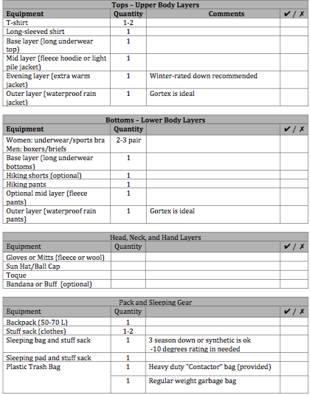 | 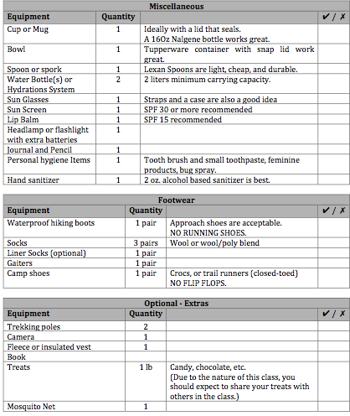
Consent Forms | For the safety of your child, it is essential that the information we have on file is current. Allergies (mild or severe) as well as food sensitivities need to be identified and brought to our attention when completing the attached consent forms. Please return the attached forms no later that Monday, June 2nd.
Emergency Contact Information | Connect Office 403-282-2890  Jason Avramenko 403-827-5501  Deirdre Bailey 403-619-5681

