Grade 6/7 Outdoor Education Elective
Quaite Valley Backcountry Excursion
June 4th to 5th, 2015

Parents, please keep this information sheet for your reference. Students must have parents review and return attached consent form and student info sheet to Mr. McKenzie, Ms. Monteith, or the Connect Office no later than Monday, June 1st in order to be eligible for participating in our upcoming trip.

Trip Details and Location | Grade 6/7 Outdoor Education students will be hiking just over 2 km from Hwy 1 to the Quaite Valley Backcountry campground carrying all of their gear necessary for an overnight stay. They will be setting up a base camp and exploring further up Jewel Pass, before returning for dinner and an overnight stay. Students will return to the trailhead the next morning.
Curricular Connections | Through participating in this trip, students will:  - Develop basic knowledge, skills and attitudes necessary for safe, comfortable outdoor experiences  - Develop understanding, respect and appreciation for self, others, and their views  - Develop awareness and appreciation of living things and an understanding of basic ecological processes  - Develop skill, judgment, confidence and through environmentally responsible outdoor activity  - Develop lifestyle strategies that foster contact with the natural world, encourage responsibility for local and global environments and encourage living in harmony with others
Depart Connect | 8:15 am (Students should arrive at school by 7:15 am.) We will be checking students’ personal gear and issuing group gear prior to departure.
Return to Connect | 2:00 pm (Please make firm arrangements for student pickup at 3:30 pm.) We will be cleaning and re-organizing group gear prior to students’ departure at 3:30pm.
Trip Leaders | Deirdre Bailey and Jocelyn Monteith will be leading this excursion. One of our school administrators and staff members will provide additional support for the leaders and students on this trip. Parent volunteers, with backcountry experience, will also be needed to provide additional support for our students on this trip.
Trip Cost | There is no fee for this trip
Transportation | Transportation will be provided by Southland Transportation
First Aid | All teachers on this trip have been certified in First Aid. Emergency services in the area have been notified of our trip dates and location. In the unlikely event that medical attention is needed, Kananaskis Emergency services in located 30 minutes from the tail head. Students with severe allergies must carry two epipens. Students with puffers should keep these with them at all times. Please send additional student medication in clearly marked containers with students’ name and instructions.
Food | Students will be preparing basic dinners (pastas) and breakfasts (oatmeal) on the trail. Students will have had an opportunity to practice cooking both meals and will be involved in food packing prior to our departure. Students will be personally responsible for purchasing and packing lunches and snacks on both days, as well as any additional food items they may want to add to their pasta dinners (meats). We ask that treats like candy, chocolate, and other sweets be limited to no more than 1 pound (454g) (please refer to the list of suggested snacks posted to Edmodo). It will be critical that all students have at least two 1-liter water bottles, and/or a Hydration System (water bottles are preferred).

Gear | (The personal gear list is the responsibility of each student)  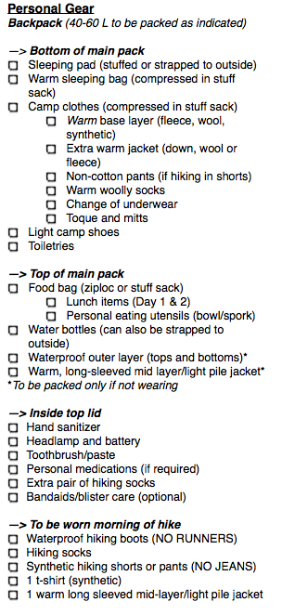 | (Group gear list items will be provided by the school and issued the morning of departure)  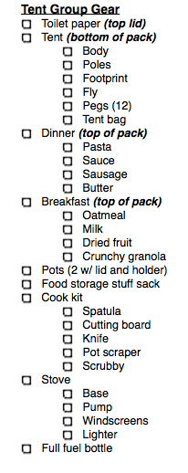
Consent Forms | For the safety of your child, it is essential that the information we have on file is current. Allergies (mild or severe) as well as food sensitivities need to be identified and brought to our attention when completing the attached consent forms.
Emergency Contact Information | Connect Office 403-282-2890  Deirdre Bailey 403-619-5681  Jocelyn Monteith

