**Connect Charter School**

**Grade 6 Winter Camp**

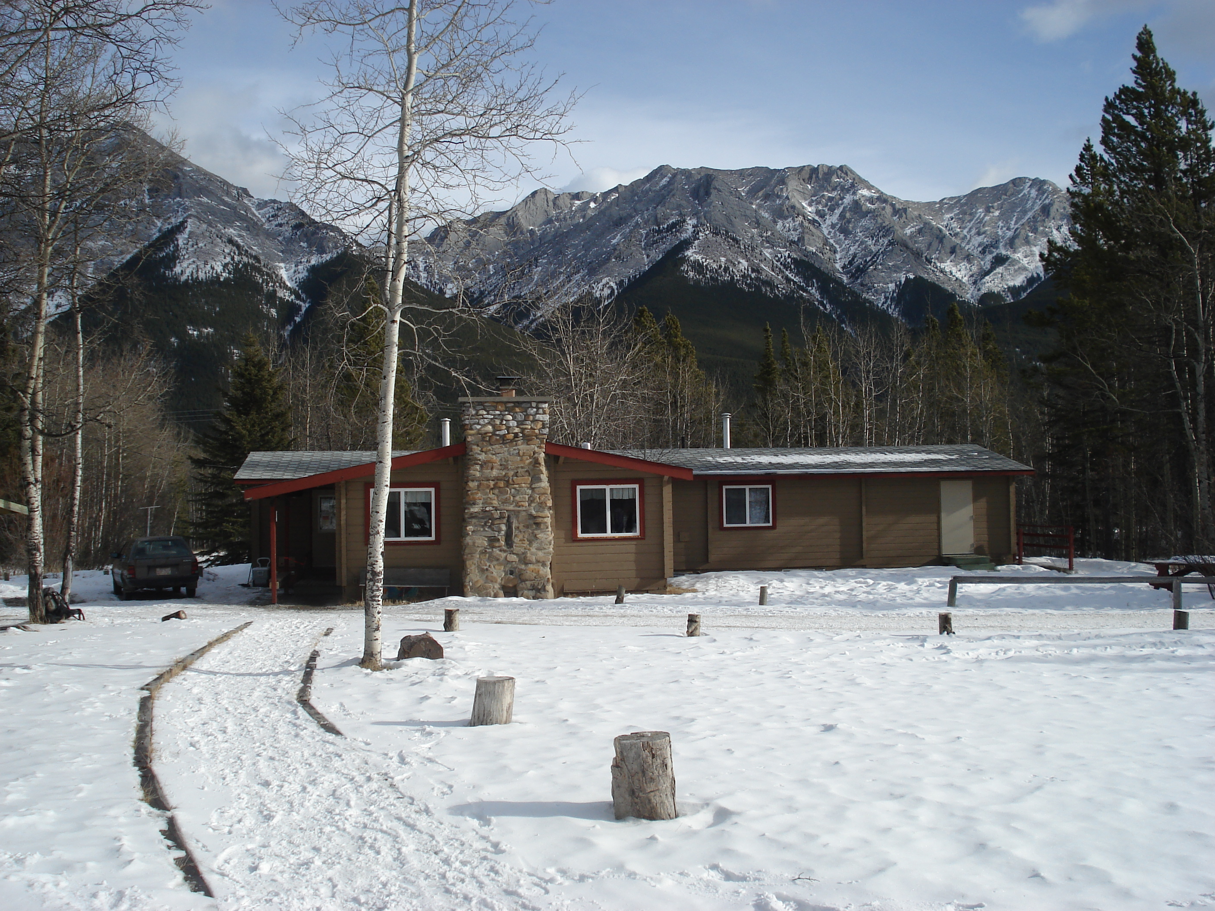

**KANANASKIS WILDERNESS HOSTEL, KANANASKIS, AB.**

**JANUARY 9 – 13 & 23 – 27, 2017**

# **PARENT INFORMATION**

**BOOKLET**

**CONNECT CHARTER SCHOOL**

**Kananaskis Winter Camp**

**General Information**

**DATES 6.1 – Jan. 9 - 11**

**6.2 – Jan. 11 - 13**

**6.3 – Jan. 23 - 25**

**6.4 – Jan. 25 - 27**

**LOCATION**

This outdoor experience will take place in and around the HI-Kananaskis Wilderness Hostel, located 70 kilometers west of Calgary on Highway 1 (Trans Canada), and 25 kilometers south on highway 40, turn right at the Nakiska Ski Hill access, cross the Kananaskis River, then left 1.5 kilometers to the hostel.

**COST**

The cost of the winter camp experience is **$185.00 per student**, due by January 9, 2017. Board policy states, “…no eligible student may be denied participation solely on the basis of inability to pay the cost.” Should you require financial assistance to cover the cost of this trip, please contact Dr. Butterfield at 282-2890 ext. 122 or by e-mail at [phil.b@connectcharter.ca](mailto:phil.b@connectcharter.ca).

**PAYMENT**

Payment should be completed on-line through the school website.

1. Go to [www.connectcharter.ca](http://www.calgaryscienceschool.com)
2. Click on “login”, then select “login as family”
3. Click on “pay fees”, then follow the steps given

**TRANSPORTATION**

Departures and Arrivals for each class are as follows:

|  |  |  |  |
| --- | --- | --- | --- |
| **6.1** | **6.2** | **6.3** | **6.4** |
| Jan 9 Depart Connect at  9:30 am | Jan 11 Depart Connect at  9:30 am | Jan. 23 Depart Connect at  9:30 am | Jan. 25 Depart Connect at  9:30 am |
| Jan 11 Arrive at Connect at 3:15pm | Jan 13 Arrive at Connect at 3:15pm | Jan 25 Arrive at Connect at 3:15pm | Jan. 27 Arrive at Connect at 3:15pm |

***Students MUST be picked up no later than 3:45pm on their return date.***

**EMERGENCY CONTACT INFORMATION**

Connect Office 403-282-2890

Phil Butterfield 403-815-3683

John Cadman 587-777-2886

Kananskis Emergency Services 1-403-591-7755

Kananaskis RCMP 1-403-591-7707

**PROGRAM**

This trip is a strong enhancement to the grade 6 academic program. The curriculum topics include:

*HUMANITIES*: Creative Writing – Nature Journals and Writing Poetry, Mythology, Constellation stories, First Nations – Shelters and winter travel.

*SCIENCE*: Evidence and Investigation: Snow Studies, Avalanche Search Training, Animal Tracking, Sky Science: Night Hikes, Star Gazing and Astronomy. Trees & Forests: Tree and plant identification

*PHYSICAL EDUCATION*: hiking, cross-country skiing, quinzee (snow shelter) building and a wide variety of games

*HEALTH*: self-awareness, accepting others, team-building and leadership development. Children learn best when they have a strong sense of ‘belonging’ with their peers and teachers. Through this three-day experience in the outdoors, we want to nurture a positive, caring ‘family’ atmosphere among our students.

**STUDENT HEALTH INFORMATION**

Parents should access the student health information in the *Family Zone* on the Connect website to ensure all details relating to medical or health conditions are current and accurate. Connect staff will use this information if the need arises during winter camp.

**FORMS**

On the second day of this trip we are using guides from Kananaskis Outfitters to facilitate a half-day cross country ski lesson and a half-day cross country ski tour on the trails around Ribbon Creek. As such, we require that you sign and return both the Connect Charter School informed consent and the Kananaskis Outfitters informed consent.

**FIRST AID / MEDICATIONS**

In the unlikely event that medical attention is needed, all guides and teachers have been trained in CPR and first aid. Emergency Services are located on Highway 40, less than a 5-minute drive from the Hostel. If your child requires medication, please send it in a clearly marked container with the child’s name and complete the medication schedule attached to the back of this book so that the teachers can make the necessary arrangements to administer the dosage. Please notify teachers in advance of the need to administer medication so a schedule can be developed accordingly.

**VOLUNTEERS**

Parent volunteers are necessary for this trip to take place. We need 4 to 5 parents for each class. Volunteer duties include making meals, organizing meal clean up, and supervising students at the direction of the teacher and guides. All prospective volunteers must have a current, valid security clearance check on file in accordance with school policy. Volunteers will be selected by the administration based on qualifications and camp needs. All prospective volunteers must complete the ***Field Studies Parent Volunteer Form***, sent home by homeroom teachers.

**FOOD**

As you can see from the attached menu, we are providing well-balanced meals. We have chosen a menu that has been successful with this age group on previous trips and that is compatible with the resources available at the hostel. Each student will be asked to bring a leak-proof water bottle.

**SNACKS**

Studentsare required to bring a group snack that is **nut free**. We will use these snacks on hikes, as campfire treats, and deserts throughout the trip. Please see the list of snack suggestions in this book or visit: <http://connectenvoe.weebly.com/winter-camp.html> for an extensive list of healthy snack suggestions compiled by the Parent Volunteer Committee. Homeroom teacher will provide a large bin to collect all the shared snacks on the departure morning of each classes trip.

**BEDDING**

All bedding is provided by the hostel. In accordance with Hostelling International policy, please **do not send sleeping bags, blankets or pillows**, as they will not be permitted in the hostel.

**CLOTHING**

**Given the potential for cold weather it is extremely important that student’s clothing is appropriate for a variety of conditions. Please make sure all clothing and equipment is clearly labeled with your child’s first and last name.**

Remember layering is the best way to stay comfortable.

**Layer 1 –** Ventilating Layer (long underwear, etc.)

**Layer 2 –** Insulating Layer (pants and sweaters)

**Layer 3 –** Waterproofing Layer (winter jacket, boots, toque, mitts etc.)

Following is a list of required clothing. The amounts indicated are minimums, students may bring additional clothing if desired. All personal gear should be packed in one duffle bag or suitcase. Students also require a day pack to carry water and snacks during outdoor activities.

|  |  |
| --- | --- |
| **Clothing:**  **Top Layers**   * Winter jacket * Toque * 2 pairs of gloves or mitts (a spare pair is essential) * Neck warmer or scarf * Warm sweaters/hoodies * 1 long underwear top *(synthetics are warmest)* * 2-3 long sleeved shirts * 2-3 T-shirts   **Bottom Layers**   * Snow pants * 2-3 pair of pants *(wool or fleece pants are best, but jeans and sweatpants will work)* * Winter boots *(waterproof, Do not apply waterproofing to summer boots)* * 2-3 pair of pants *(wool or fleece pants are best, but jeans will work)* * 3 pairs of underwear * 1 pair long underwear bottoms *(synthetics are warmest)* * 6 pair of sport socks *(for inside use)* * 3 pair of warm **wool** socks *(for outside use)* * Pajamas * Slippers | **Personal Gear**   * Toothbrush and toothpaste * 1 towel * Comb or brush * Sunscreen * Lip balm * Water bottle (leak proof) * Sunglasses * Flashlight or Headlamp * Book   **IMPORTANT NOTE: Students are not to bring any electronic devices, including games, iPods, or cell phones to camp or on the bus.** |
| **Optional Items**   * Camera * Stuffy/Teddy Bear * Cards/Board Game |
| **Food**   * Snack for the bus * Hearty bag lunch for the first day * Group snack |

**Grade 6 WINTER CAMP 2017**

|  |  |  |  |
| --- | --- | --- | --- |
| **Times** | **Day 1** | **Day 2** | **Day 3** |
| **7:30-8:30** | A flurry of excitement will be present among all who are heading to winter camp. | Breakfast @ 8:00 | Breakfast @ 8:00 |
| **8:30-12:30**  **Snack**  **~10:30** | **Activity 2:**  Meet Ski Guides  XC Ski Lesson | **Move out of Dorms** |
| **Leave Connect by 9:30**  (1.5 hr. drive) | **Activity 4:**  Snow Science  Animal Game  Demolish Quinzees |
| -Move bags in only.  -Expectations and boundaries  -Exploration and cooperative games. |
| **Early Lunch**  **11:30-12:15** |
| **LUNCH**  **12:15-1pm** | Bag Lunch brought from home by students. | **Activity 3: (**12:15-2:15**)**  **Ski Trip** | See Menu  *Will eat outside if weather permitting |
| **1:00-4:30**  **Snack**  **~2:30** | **Move into Dorms**  **-**Meet Hostel Custodian | **Trip Debrief**  -Gratitude Circle |
| **Activity 1:** (1:30/2pm start)  Winter Camping Lesson  Pile Quinzees | **Activity 4:** (2:30 – 4:30)  Dig out Quinzees  Quinzee decorating | **1:45** Departure  **3:00** Arrival at Connect |
| *Note to Parent Volunteers:  Each day, we will have snack/bathroom breaks in the mornings (around 10:30-11:00) and in the afternoons (around 2:30-3:00) unless groups are out skiing. If skiing, arrangements will be made to have trail snacks. |
| **4:30-5:30** | **Free Time**: Games, cards, read, journaling, get dry, get warm, etc | |
| **DINNER**  **5:30-6:30** | **See Menu** | **See Menu** |
| **6:30-7:00** | Clean-up / Free Time | Clean-up / Free Time |
| **7:00-8:00** | Night Hike & Star Gaze | Visit Quinzees &  Star Gazing |
| **8:00-9:00** | Hot Chocolate & Treat  Tin Can Constellations & Myths | Hot Chocolate & Treat  Tin Can Constellations & Myths |
| **9:00-9:30** | PJ’s and Teeth brushing | PJ’s and Teeth brushing |
|  | Bedtime | |

**Winter Camp Menu 2017**

|  |  |  |
| --- | --- | --- |
| DAY 1 | SUPPER  SNACK | * Hamburgers (Beef and Veggie) * Buns * Cheese, lettuce, tomato, onion ketchup, relish, mustard, pickles * Raw veggie sticks * Chips * Milk/Chocolate milk * Water * Fruit Salad   Hot Chocolate / Fresh Fruit / Baked Goods |
| DAY 2 | BREAKFAST | * Pancakes * Sausage * Hot Chocolate * Milk * Juice * Orange slices |
|  | LUNCH | * Pasta and sauce * Steamed mixed vegetables * Raw veggie sticks * Milk / Water |
|  | SUPPER  SNACK | * Sloppy Joes * Buns * Caesar Salad * Milk/Chocolate Milk/Juice * Frozen yogurt / fruit   Hot Chocolate / Fresh Fruit / Baked Goods |
| DAY 3 | BREAKFAST | * Cereal * Granola * Yogurt * Fresh fruit * Milk / Juice / Water |
|  | LUNCH | * Sandwiches (buns, meat, cheese, veggies) * Buns * Juice boxes / Water * Raw veggies * Granola bar * Fruit / cookies / baked goods |

*Vegetarian options available. **Please notify teachers of any dietary requirements or restrictions.**

**Snack Recipe Suggestion**

Make sure the snack is Peanut Free. Please note, ***these suggestions are not vegetarian options***. For more snack suggestions visit: http://connectenvoe.weebly.com/winter-camp.html

**Bits and Bites**

INGREDIENTS:

|  |  |
| --- | --- |
| 1 med. box Cheerios (4 cups.)  1 med. box Shreddies or Wheat Chex (5 cups.)  1 med. box Rice Chex (4 cups.)  1 large pkg. small Salted Pretzels (2 cups.)  1 small Box cheese stix (1 cups.) | 1 lb. Margarine (1/2 lb.)  6-7 Tbs. Worcestershire Sauce  1 1/2 Tbs. Garlic Powder (2 tsp.)  1 1/2 Tbs. Onion Powder (2 tsp.)  1/2 Tbs. Celery Salt (1 tsp.)  2 Tbs. Seasoning Salt (3 tsp.) |

DIRECTIONS:

Preheat oven to 250°F.

Mix the cereals, nuts, pretzels and cheese stix together in a very large bowl or pot. Melt the margarine in a pot on fairly low heat. Add in the Worcestershire and seasonings and mix well. Put about 1/2 the cereal mix in a large roasting pan and spread with half the sauce. Cover with the rest of the cereal mixture and then spread the rest of the sauce over. Mix well! Put uncovered in the oven. STIR EVERY 15 MINUTES! Bake for at least 1 hour. Should be done but test for taste and crispiness. Will crispen even more when cold (if it hasn't been eaten by then).

**Chewy Ginger Molasses Cookies**

INGREDIENTS:

|  |  |
| --- | --- |
| * 1 ½ cups butter, softened * 2 cups granulated sugar * ½ cup molasses * 2 eggs * 4 cups all-purpose flour | * 2 teaspoons baking soda * 2 teaspoons ground cinnamon * 1 teaspoon ground cloves * 1 teaspoon ground ginger * 1 teaspoon salt |

DIRECTIONS:

Preheat oven to 375°F.

In a medium bowl, whisk together flour, soda, cinnamon, cloves, ginger and salt. Set aside.

In the bowl of an electric stand mixer, beat together butter and sugar on medium speed for 1 minute until light and fluffy.  Add in the eggs and molasses, and beat on medium-low speed until combined. Gradually add in the dry ingredient mixture and beat until combined. Roll the dough into small balls, about 1-inch in diameter. Fill a small bowl with sugar, and roll each ball in the sugar until it is completely coated. Place on cookie sheet at least 1 inch apart**, then bake for about 8-10 minutes, until the cookies begin to slightly crack on top.  (They may crack more while cooling.)  Remove from the oven and let cool for a minute or two. Then transfer to wire racks to cool completely.

Serve immediately or store in a sealed container for up to 1 week.

**Chocolate Puffed Wheat Squares**

|  |  |
| --- | --- |
| * 8 cups puffed wheat cereal * 3 tablespoons unsweetened cocoa powder * 1/3 cup corn syrup | * 1/4 cup packed brown sugar * 1/3 cup butter or margarine |

DIRECTIONS:

Place puffed wheat in a large bowl, and set aside. Grease one 9x9 inch pan. Grease the rim of a medium saucepan to prevent boil-over. Place the cocoa powder, corn syrup, brown sugar, and butter or margarine in the saucepan. Cook over medium heat, stirring often until mixture comes to a full boil. Allow to boil for 1 minute, and then remove from heat. Pour chocolate mixture over puffed wheat, and stir until puffed wheat is evenly coated. Using a buttered spatula, press mixture into the prepared pan. Allow to cool, then cut as desired. Wrap squares individually, or store in an airtight container.



**CONNECT CHARTER SCHOOL**

**INFORMED CONSENT AND ACKNOWLEDGEMENT OF RISK FORM**

**GRADE 6** **WINTER CAMP**

THIS CONSENT AND ACKNOWLEDGEMENT OF RISK FORM MUST BE READ AND SIGNED BY A PARENT OR GUARDIAN OF ANY STUDENT PARTICIPATING IN OFF CAMPUS ACTIVITIES.

PLEASE READ THIS INFORMED CONSENT AND ACKNOWLEDGMENT OF RISK FORM CAREFULLY, TOGETHER WITH ANY ACCOMPANYING DOCUMENTATION AND DIRECT ANY QUESTIONS TO SCHOOL ADMINISTRATION BEFORE INDICATING ACCEPTANCE.

**ACTIVITY DETAILS**

DESTINATION / ACTIVITY: Ribbon Creek, Kananaskis – Grade 6 Winter Camp

DATE (S): January 9-11, 11-13, 23-25, or 25-27, 2017 (3 days, 2 nights per class)

CURRICULAR OUTCOMES: See information booklet

ITINERARY / ACTIVITIES: See information booklet

PER STUDENT COST (if applicable): **$185.00**

WHAT STUDENTS NEED TO BRING: See information booklet

METHOD OF TRANSPORTATION: **Fenton Bus Lines**

SCHOOL CONTACT: **Office 403-282-2890** SUPERVISION RATIO: **6:1**

NO. OF PARENT VOLUNTEERS REQUIRED: **4 to 5 per class**

**STUDENT AND EMERGENCY CONTACT INFORMATION:**

STUDENT NAME: _________________________________ HOMEROOM:_________

EMERGENCY CONTACT NAME: ___________________________________________

TELEPHONE: DAY ______________________ EVENING _______________________

**BOARD RESPONSIBILITIES**

**The Board of Connect Charter School will make every reasonable effort to ensure that:**

1. Staff, volunteers, and/or service providers are suitably trained and qualified to lead this activity/program.
2. Students will be adequately supervised during all aspects of the program / activity.
3. The location(s) used for this activity/program are appropriate for the planned itinerary and group.
4. Equipment used for this activity/program has/have been inspected and deemed safe.
5. A Safety Plan has been developed to identify and manage known potential risks.
6. An Emergency Plan is in place to deal with an injury or illness to any student.

**POTENTIAL RISKS AND PERILS ASSOCIATED WITH PARTICIPATION IN THIS ACTIVITY INCLUDE BUT ARE NOT LIMITED TO:**

**Transportation**

☐ Traffic accidents, incidents, and mishaps while a passenger on a highway coach or leased school bus

☐ Being struck by a moving vehicle

**Environmental**

☐ Weather related causes, including but not limited to: hypothermia, lightning strike, heat

stroke, heat exhaustion, and dehydration.

☐ Interaction with wildlife, including but not limited to encounters with bears, cougars, elk,

wolves, coyotes, moose, porcupine, badgers, spiders, snakes, insects.

☐ Contact with, or ingestion of, plants, berries, roots, or bark.

**Food**

☐ Choking during planned or unplanned meal times.

☐ Allergic responses, including anaphylactic shock, as a result of direct or indirect contact

with food products, byproducts, or waste.

**Pre-existing medical conditions**

☐ As identified on the student health information form.

**Activity related perils**

**Winter Camp**

☐ trauma or asphyxiation due to collapse of a snow structure.

☐ head injury or trauma as a result of cross country skiing or snowshoeing and collision with surrounding trees, rocks, people, the ground, or other objects.

☐ cold weather related trauma, including but not limited to: frostbite, hypothermia.

☐ burns due to close proximity to campfire or lighting a fire starter.

# **ACKNOWLEDGEMENT OF RISKS**:

I HAVE READ THE ABOVE, AND UNDERSTAND THAT BY PARTICIPATING IN THE ACTIVITY DESCRIBED HEREIN, I AM ASSUMING THE RISKS ASSOCIATED WITH DOING SO ON BEHALF OF THE STUDENT NAMED ON THIS FORM. THE RISK OF SUSTAINING AN INJURY OR DEATH MAY OCCUR FROM THE NATURE OF THE ACTIVITY AND CAN OCCUR WITHOUT FAULT OF EITHER THE STUDENT, OR THE SCHOOL BOARD, ITS’ EMPLOYEES/AGENTS. BY CHOOSING TO TAKE PART IN THIS ACTIVITY, YOU ARE ACCEPTING THE RISK THAT YOUR CHILD MAY BE INJURED OR KILLED.

Signature of Parent/Guardian __________________________________ Date ________________

# **INFORMED CONSENT**:

I give __________________________________ consent to participate in the **Grade 6 Winter Camp** to be

(Name of student)

held on or about **January 9-13 & 23-27, 2016**

Signature of Parent/Guardian __________________________________ Date ________________

If your child requires scheduled medication to be given while at camp, please send it in a clearly marked container with the child’s name and complete this medication schedule. Medication and medication schedule must be given to your child’s homeroom teacher.

